Distributed Computing CA 1

# Simple Message Protocol

Jack Patterson T00217640

## 1 Summary

This document will outline a simple message protocol which will securely upload and download short messages to and from a server utilising TCP Sockets and SSL. This will detail the protocol design and will also provide a sample implementation of the protocol in Java.

## 2 Contents

Simple Message Protocol 1

1 Summary 2

2 Contents 2

3 Introduction 2

4 Section 1: Design 4

4.1 Message Types 4

4.1.1 Login 4

4.1.2 Logout 4

4.1.3 Upload Message 5

4.1.4 Get Messages 5

4.2 Sequence Diagrams 6

4.2.1 Login 6

4.2.2 Login 6

4.2.3 Login 6

4.2.4 Login 6

5 Section 2: Software Architecture & Implementation 6

6 Conclusions 6

7 Appendices 6

## 3 Introduction

This document outlines a simple message protocol, hereby referred to as “SMP”, which use stream sockets to securely and concurrently send messages and download messages to and from a server. The SMP protocol will have four message types, each containing a command, which are as follows: login, log off, send message, get messages. The document will first outline the design of the protocol and will then provide a sample implementation in Java of the protocol.

## 4 Section 1: Design

### 4.1 Message Types

All messages follow the same structure. The SMP protocol is composed of three required fields which are necessary for the protocol to work: the status code, a command and a message. The status code is an integer, and the status code and the message are strings.

#### 4.1.1 Login

The first message type sends a login request. This requires a username and password as parameters separated by spaces in the message field.

Command: login

Message/Parameters: [username] [password]

Response:

Code: 200

Command: server_response

Message: Log in successful

Response:

Code: 400

Command: server_response

Message: Command requires 2 argument(s). Please provide [number of extra arguments] more argument(s).

Response:

Code: 400

Command: server_response

Message: Error logging you in. Please try again.

#### 4.1.2 Logout

The next message type sends a log out request. This requires no parameters but it should not be triggerable unless the user is logged in.

Command: logout

Message/Parameters: N/A

Response:

Code: 200

Command: server_response

Message: Logging you off. Connection is being closed.

#### 4.1.3 Upload Message

This next message type sends an upload message request. This requires the user to be logged in and to have a message they wish to be saved in the message field.

Command: uploadmessage

Message/Parameters: [message]

Response:

Code: 200

Command: server_response

Message: Message saved successfully.

Response:

Code: 400

Command: server_response

Message: Command requires 1 argument(s). Please provide [number of extra arguments] more argument(s).

#### 4.1.4 Get Messages

This final message type sends a get messages request. This requires the user to be logged in and, optionally, give a position of the message they wish to retrieve. NOTE: Position is not an index of an array is in actually [index+1].

Command: getmessages

Message/Parameters: [position of message]

Response:

Code: 200

Command: server_response

Message: Messages: [[messages]].

Response:

Code: 200

Command: server_response

Message: Message at position 1: [message]

Response:

Code: 400

Command: server_response

Message: There are not enough messages for that position. There are currently only [messages count] messages.

Response:

Code: 400

Command: server_response

Message: Argument was not an integer. Please try again.

### 4.2 Sequence Diagrams

#### 4.2.1 Login

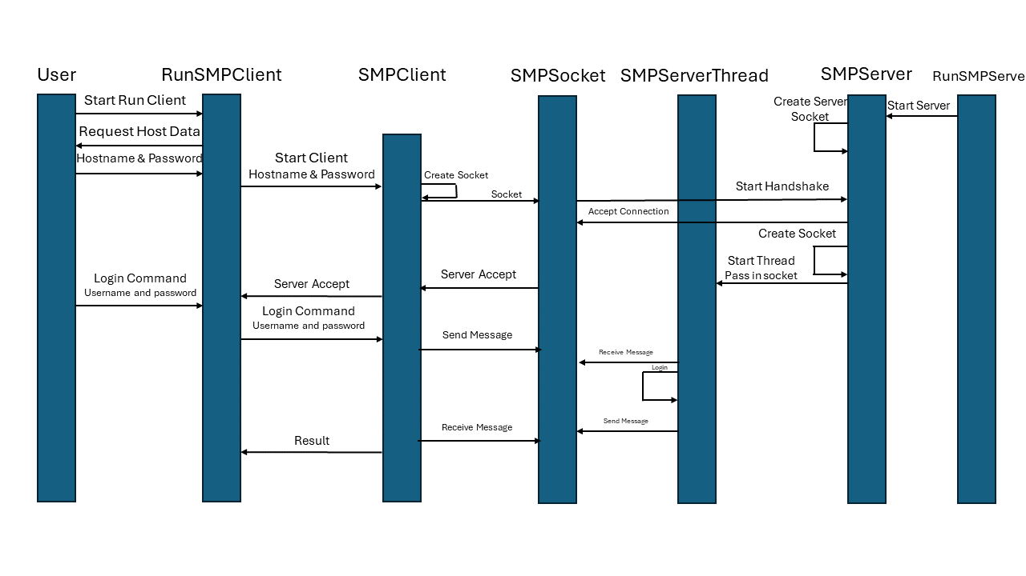

#### 4.2.2 Logout

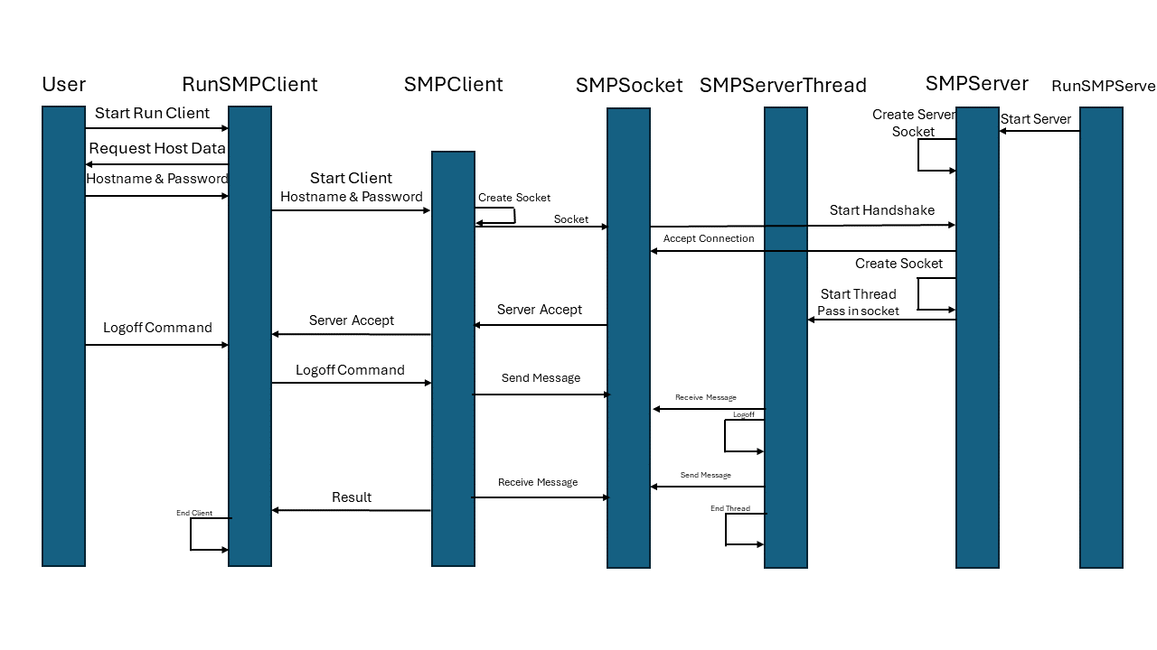

#### 4.2.3 Upload Message

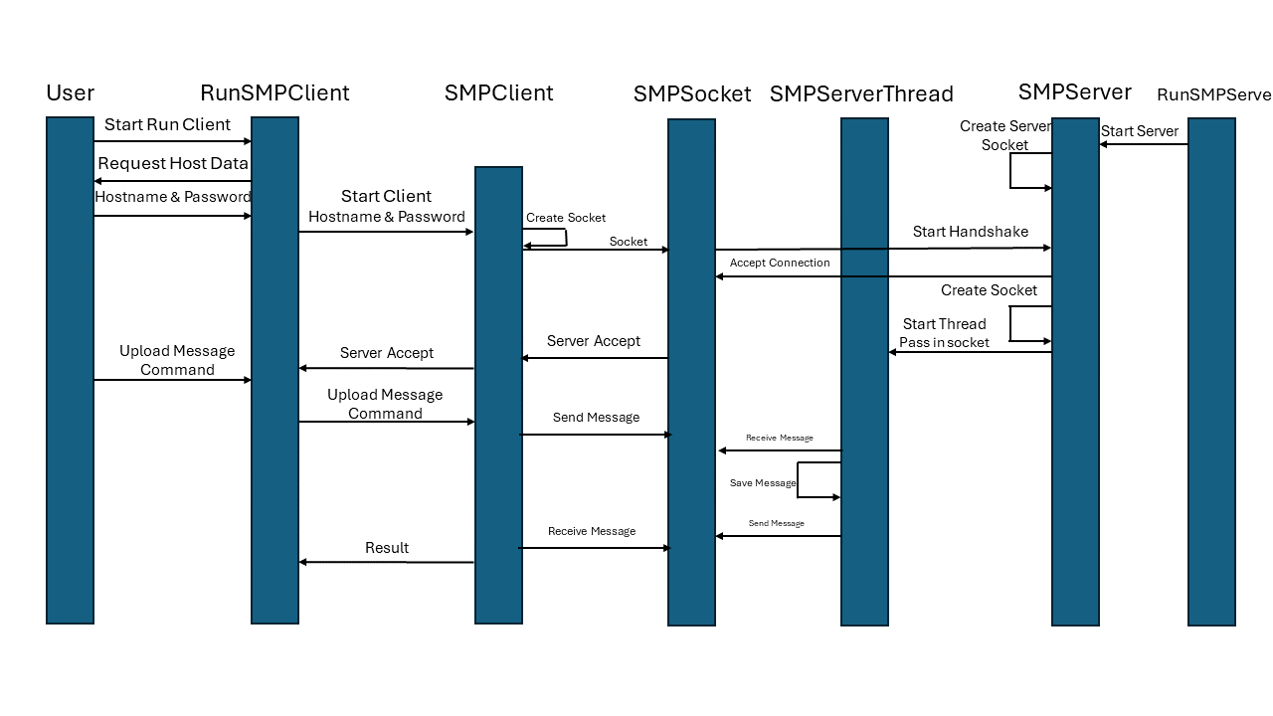

#### 4.2.4 Get Messages

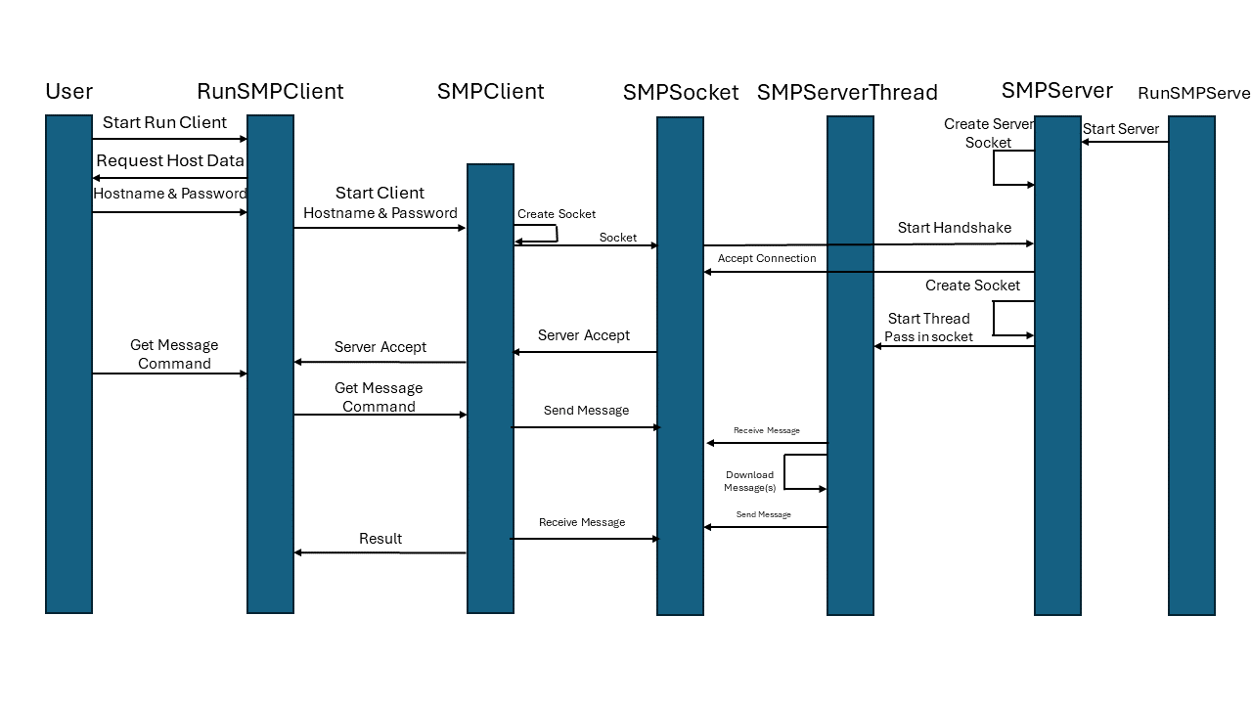

## 5 Section 2: Software Architecture & Implementation

### 5.1 Architecture Description

The architecture consists of six (or seven, as two RunSMPClient classes exist which are interchangeable) core classes which encompasses all the necessary functionality.

For presentation, that is contained in the RunSMPServer, RunSMPClientCLI and RunSMPClientGui classes. RunSMPServer acts as the interface with which the server is run and is also responsible for instantiating the server. The two RunSMPClient classes have the responsibility of displaying the details of the client as is appropriate. The actual logic for the client has been abstracted away and is instantiated the same way the server is to allow for it to function however is necessary as displayed below.

The SMPServer, SMPServerThread and SMPClient classes are in the architecture layer and are instantiated by the presentation layer. The server is entirely self-contained and listens for incoming connections before creating a thread and passing responsibility and the socket to the thread. The thread will then run and handle all messaging within it. All validation such as command validation and log in credentials validation handle from this. For the purposes of the implementation, this has been extended further and a CommandService class was established which was used to handle and run commands which all inherit from a base class Command. This was done to reduce reuse and facilitate executing the various commands easier. For example, there is a GetMessages command which contains all logic for retrieving messages contained within it. Finally, the client works differently and instead returns values. Outputs are returned to the presentation layer classes which can then choose what to do next. This was done with the thoughts that this allows for it to be extended further and interface with other theoretical application types.

The SMPSocket is the session layer and contained a secured SSLSocket within. This class has all details about the session and all functionality to do so contained within it and it is not exposed elsewhere. Google’s GSON package (Google, 2024) is also utilised for the messaging to transfer data. The data is serialised and deserialised from the SMPMessage record (basic data class).

### 5.2 Class Diagrams

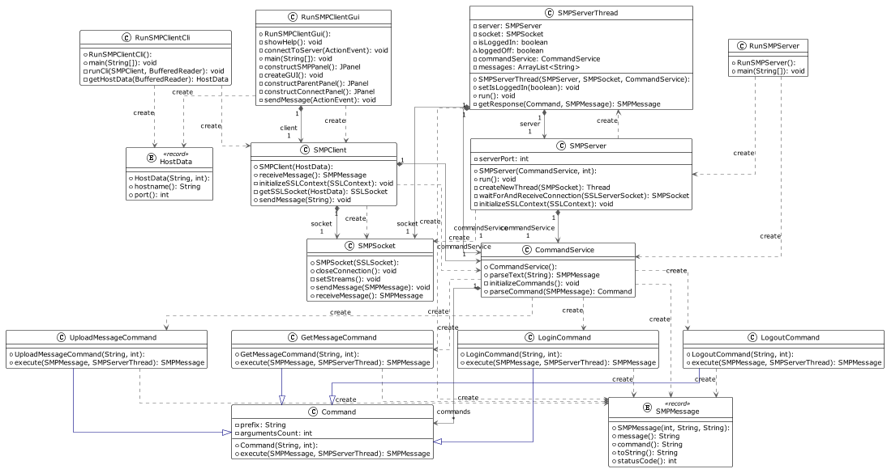

Note: I am aware of how small it is. I have included the image alongside the IntelliJ UML and PlantUML files used to generate it in a folder called “[Diagrams](https://github.com/Jack-Patterson/DistributedComputingCA/tree/main/Diagrams)”.

### 5.3 Code Snippets

They are all displayed below in the appendices from 7.1-7.3. They take up 17 pages, so I deemed it more appropriate to include them at the bottom.

### 5.4 Outputs

#### 5.4.1 Client CLI

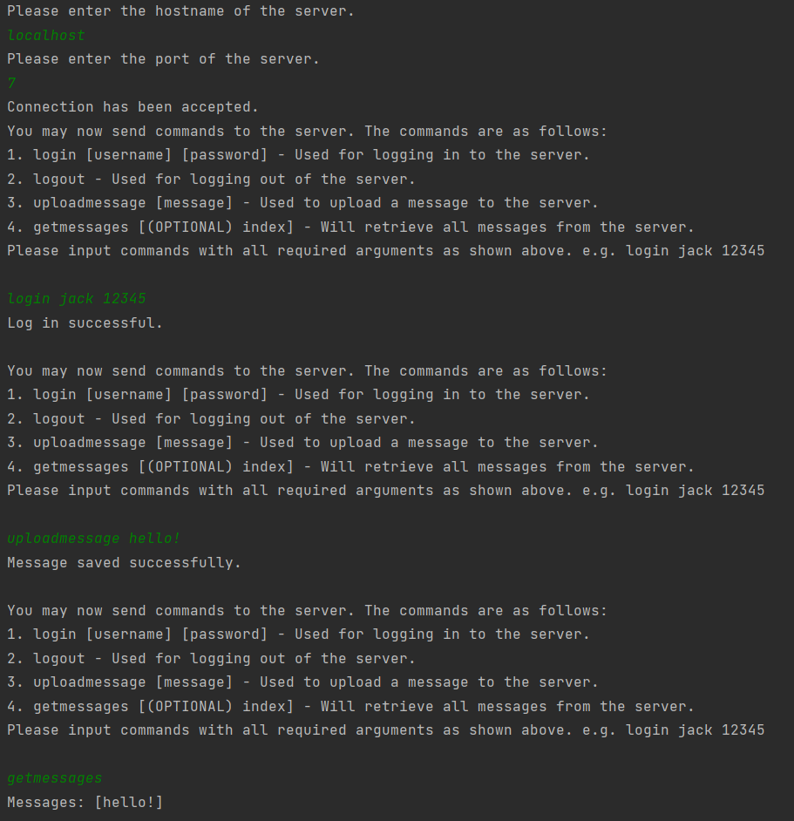

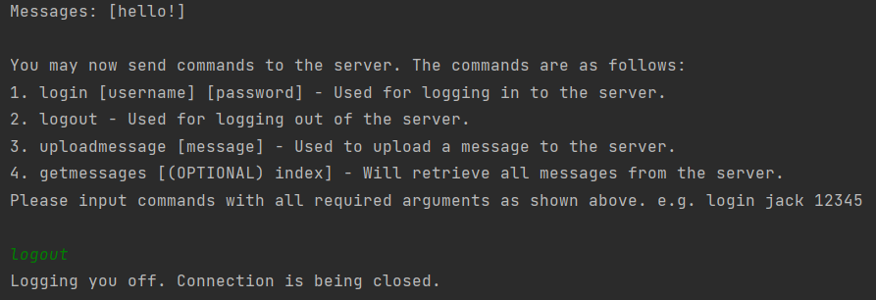

#### 5.4.2 Client Gui

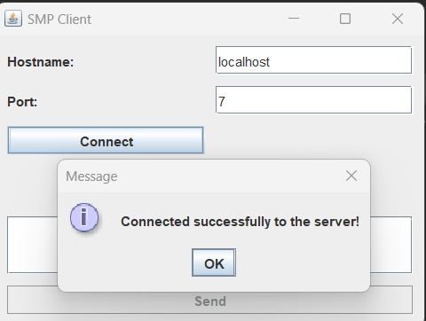

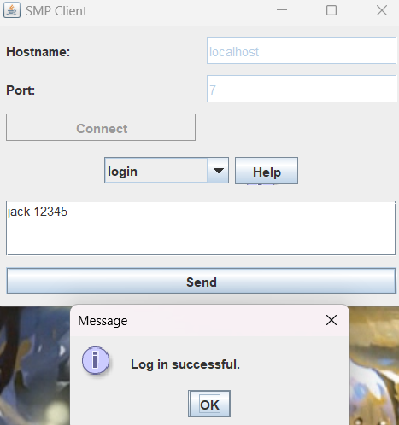

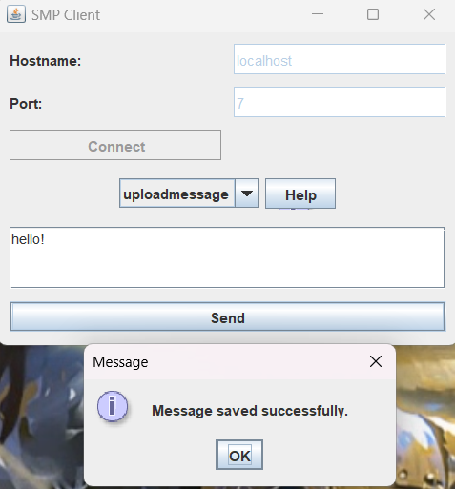

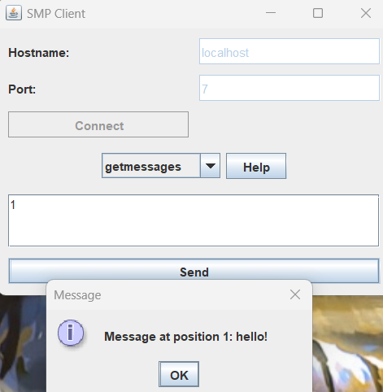

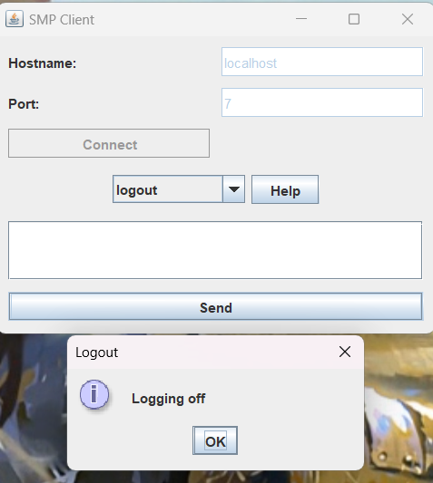

#### 5.4.3 Server

Note: This is what was printed to the console in response to the CLI and GUI clients respectively.

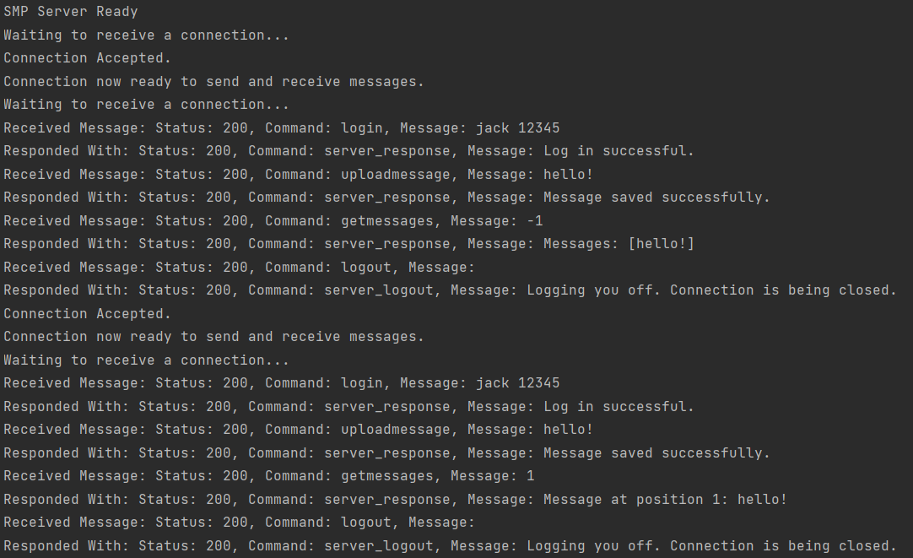

### 5.5 How to run the code

There are two main ways to run the code: run it via IntelliJ or via the command line.

Note that the command line arguments are long due to using the GSON package which was outlined above and also as it was built in IntelliJ so it adheres to its structure.

If any commands do not copy and paste well into the command line there is a file included in the main directory called “HOW_TO_RUN.txt” which contains all commands.

Command Line:

Open command line in the main directory (DistributedComputingCA folder).

Run the following commands:

CLIENT CLI = java -classpath out\production\DistributedComputingCA;Dependency\gson-2.10.1.jar pattersonjack.distributedcomputingca.Client.RunSMPClientCli -Djavax.net.ssl.trustStore=ssl/public.jks -Djavax.net.ssl.trustStorePassword=123456789

CLIENT GUI = java -classpath out\production\DistributedComputingCA;Dependency\gson-2.10.1.jar pattersonjack.distributedcomputingca.Client.RunSMPClientGui -Djavax.net.ssl.trustStore=ssl/public.jks -Djavax.net.ssl.trustStorePassword=123456789

SERVER = java -Djavax.net.ssl.keyStore=ssl/dcca.jks -Djavax.net.ssl.keyStorePassword=123456789 -classpath "out\production\DistributedComputingCA;Dependency\gson-2.10.1.jar" pattersonjack.distributedcomputingca.Server.RunSMPServer

Intellij:  
Open main directory.

Add gson package as a dependency if it is not by default.

Add run arguments:

CLIENT CLI/GUI = -Djavax.net.ssl.trustStore=ssl/public.jks -Djavax.net.ssl.trustStorePassword=123456789

SERVER = -Djavax.net.ssl.keyStore=ssl/dcca.jks -Djavax.net.ssl.keyStorePassword=123456789ó

Run the files using the run configurations with the arguments.

## 6 Conclusions

This document aimed to create a simple messaging protocol (SMP) to securely and concurrently upload and download messages from a server using TCP Stream Sockets utilising SSL as security. It was implemented in Java, designed in a way to be extendable and interfaceable by other programs. This was a chieved successfully, with both a graphical user interface and command line interface being made available, and it is done both securely and concurrently.

## 7 Appendices

#### 7.1 Client

##### 7.1.1 RunSMPClientCLI



##### 7.1.2 RunSMPClientGui

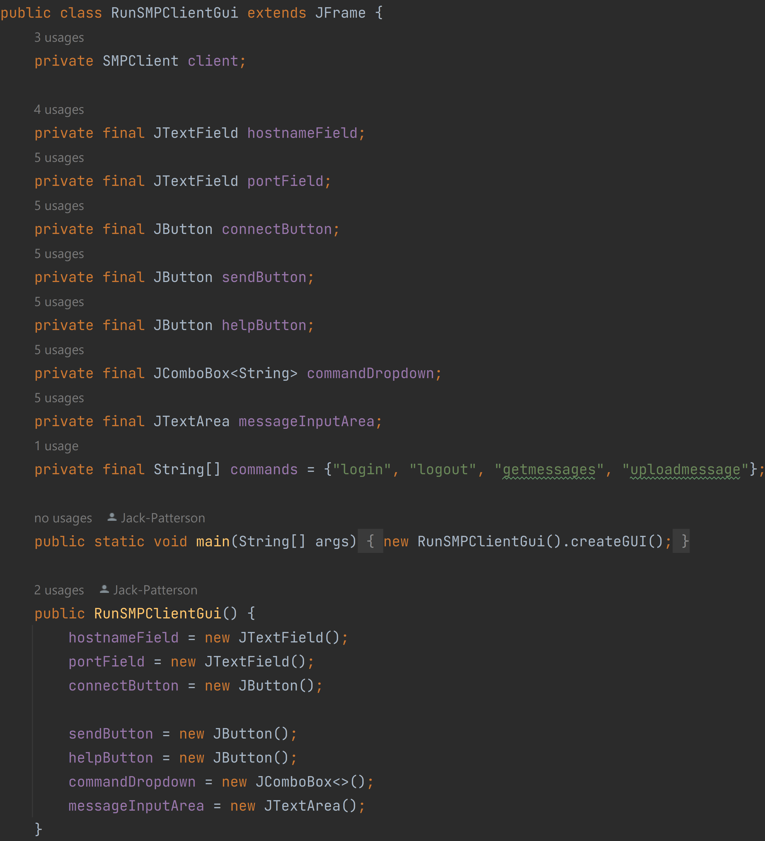





##### 7.1.3 SMPClient



#### 7.2 Server

##### 7.2.1 RunSMPServer

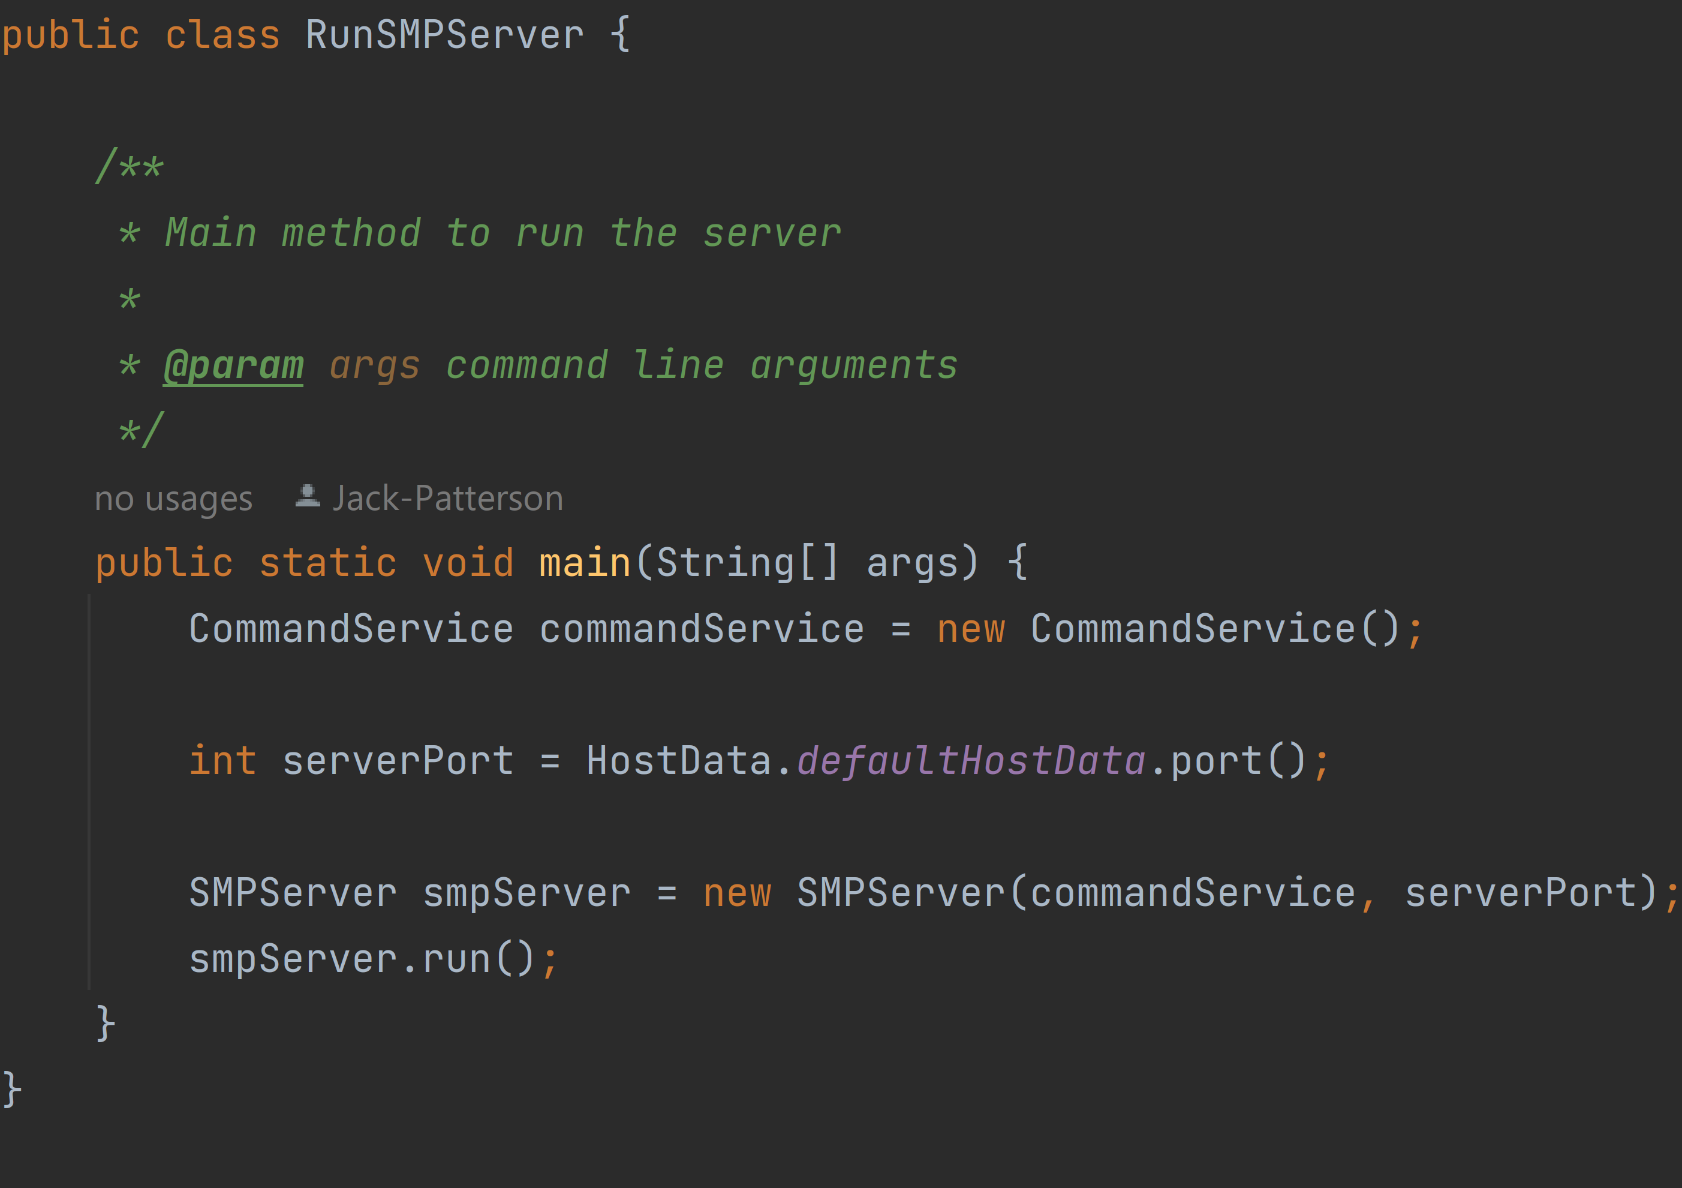

##### 7.2.2 SMPServer

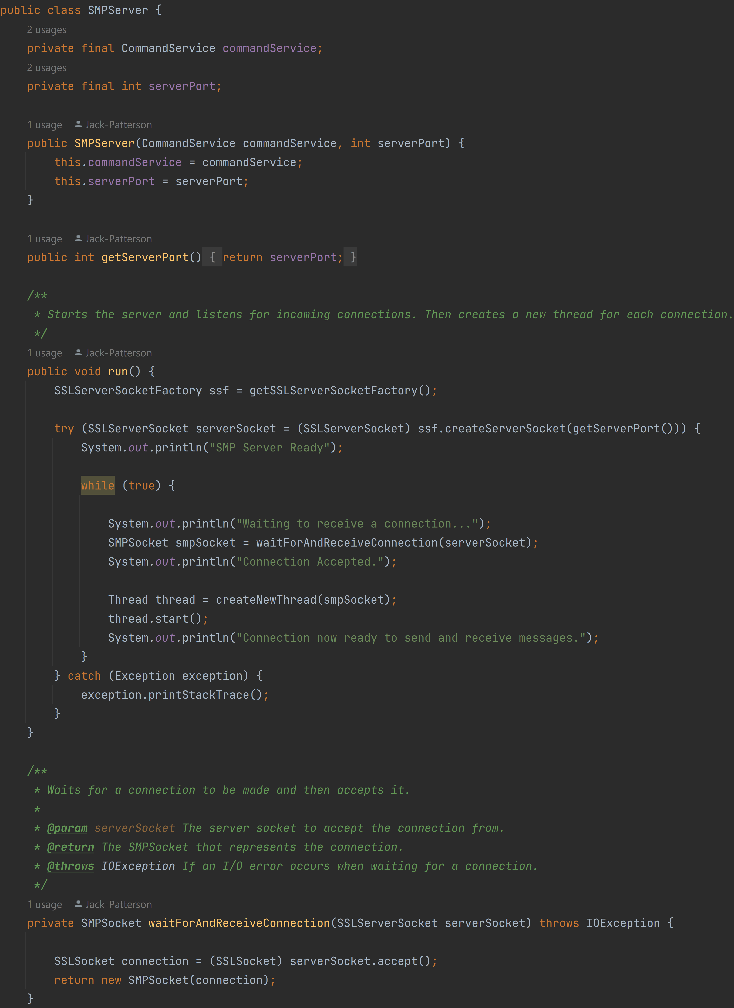

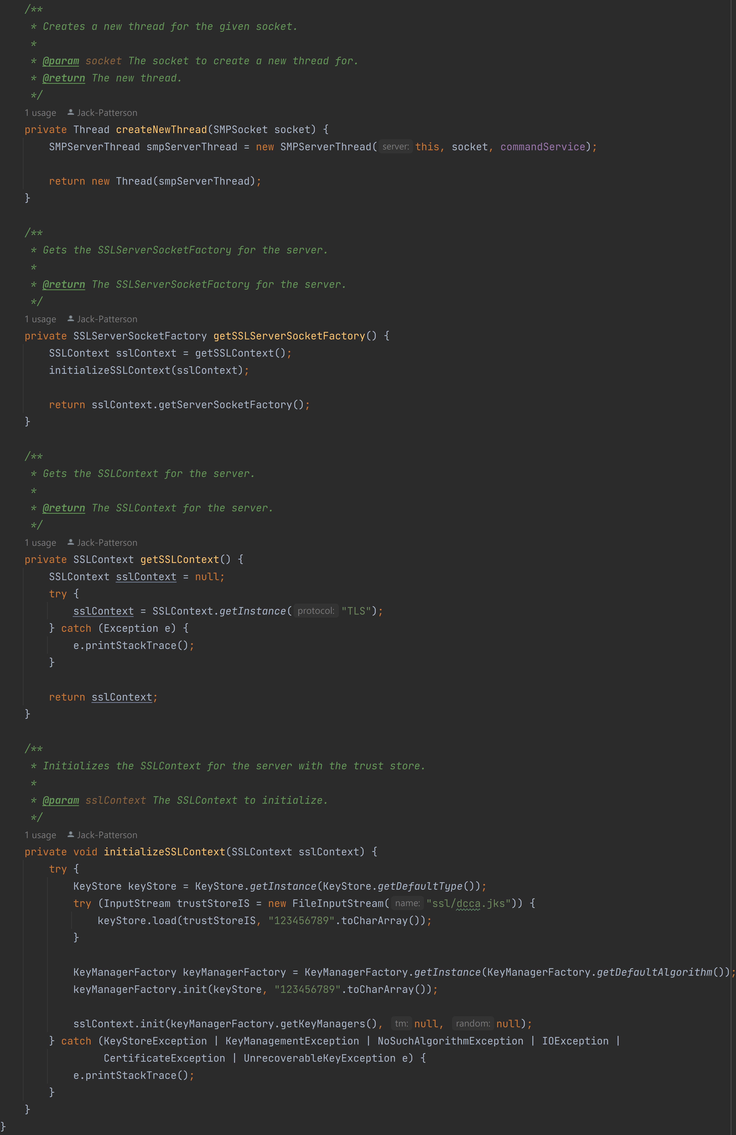

##### 7.2.3 SMPServerThread



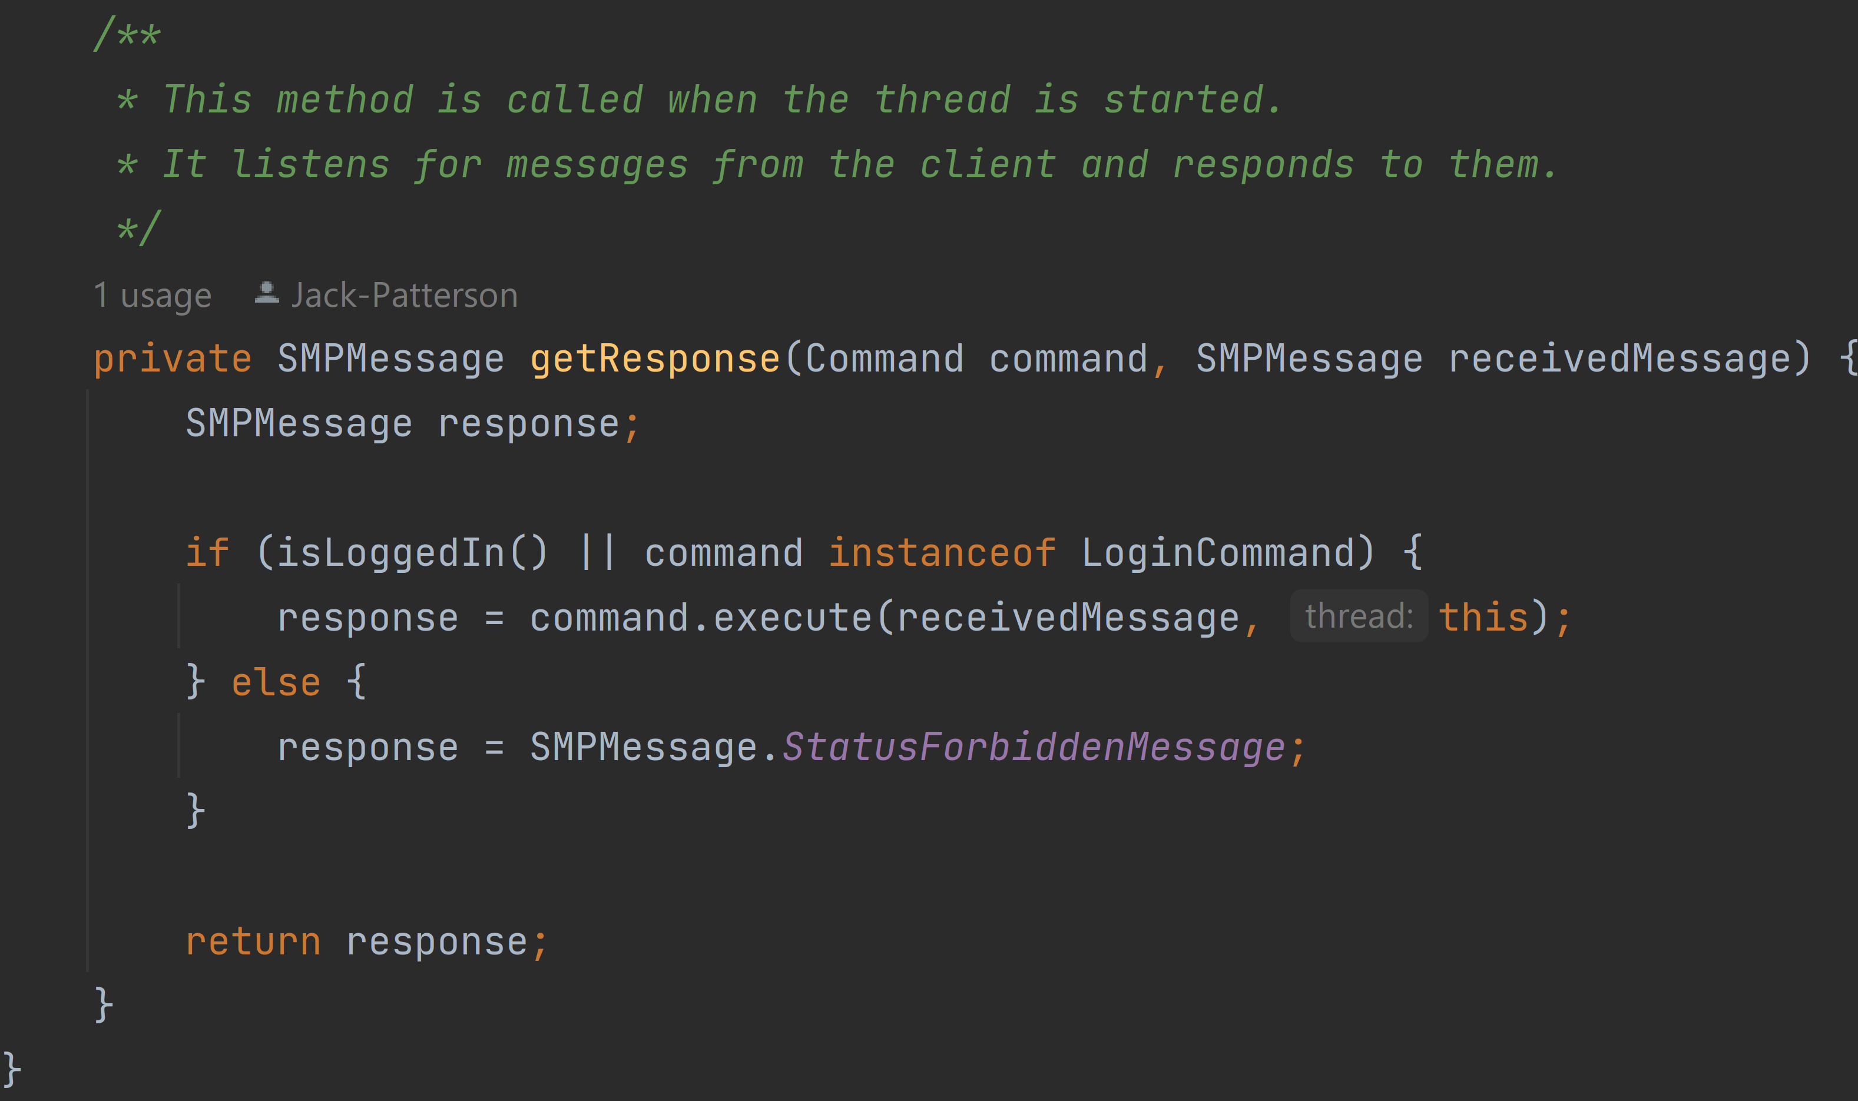

#### 7.3 Shared

##### 7.3.1 SMPSocket

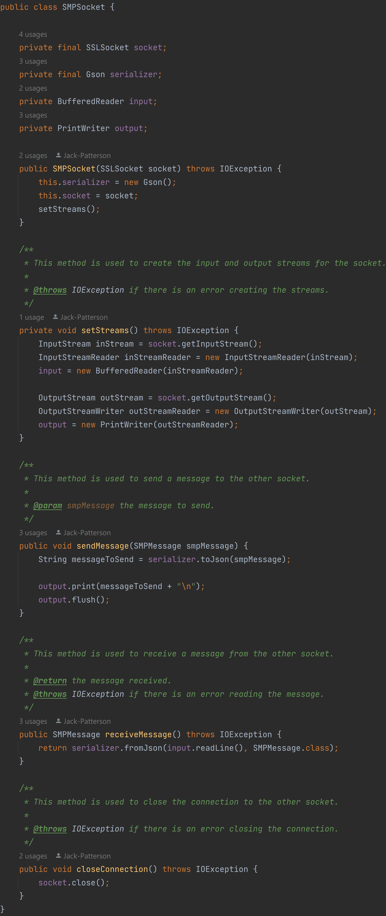

##### 7.3.2 SMPMessage

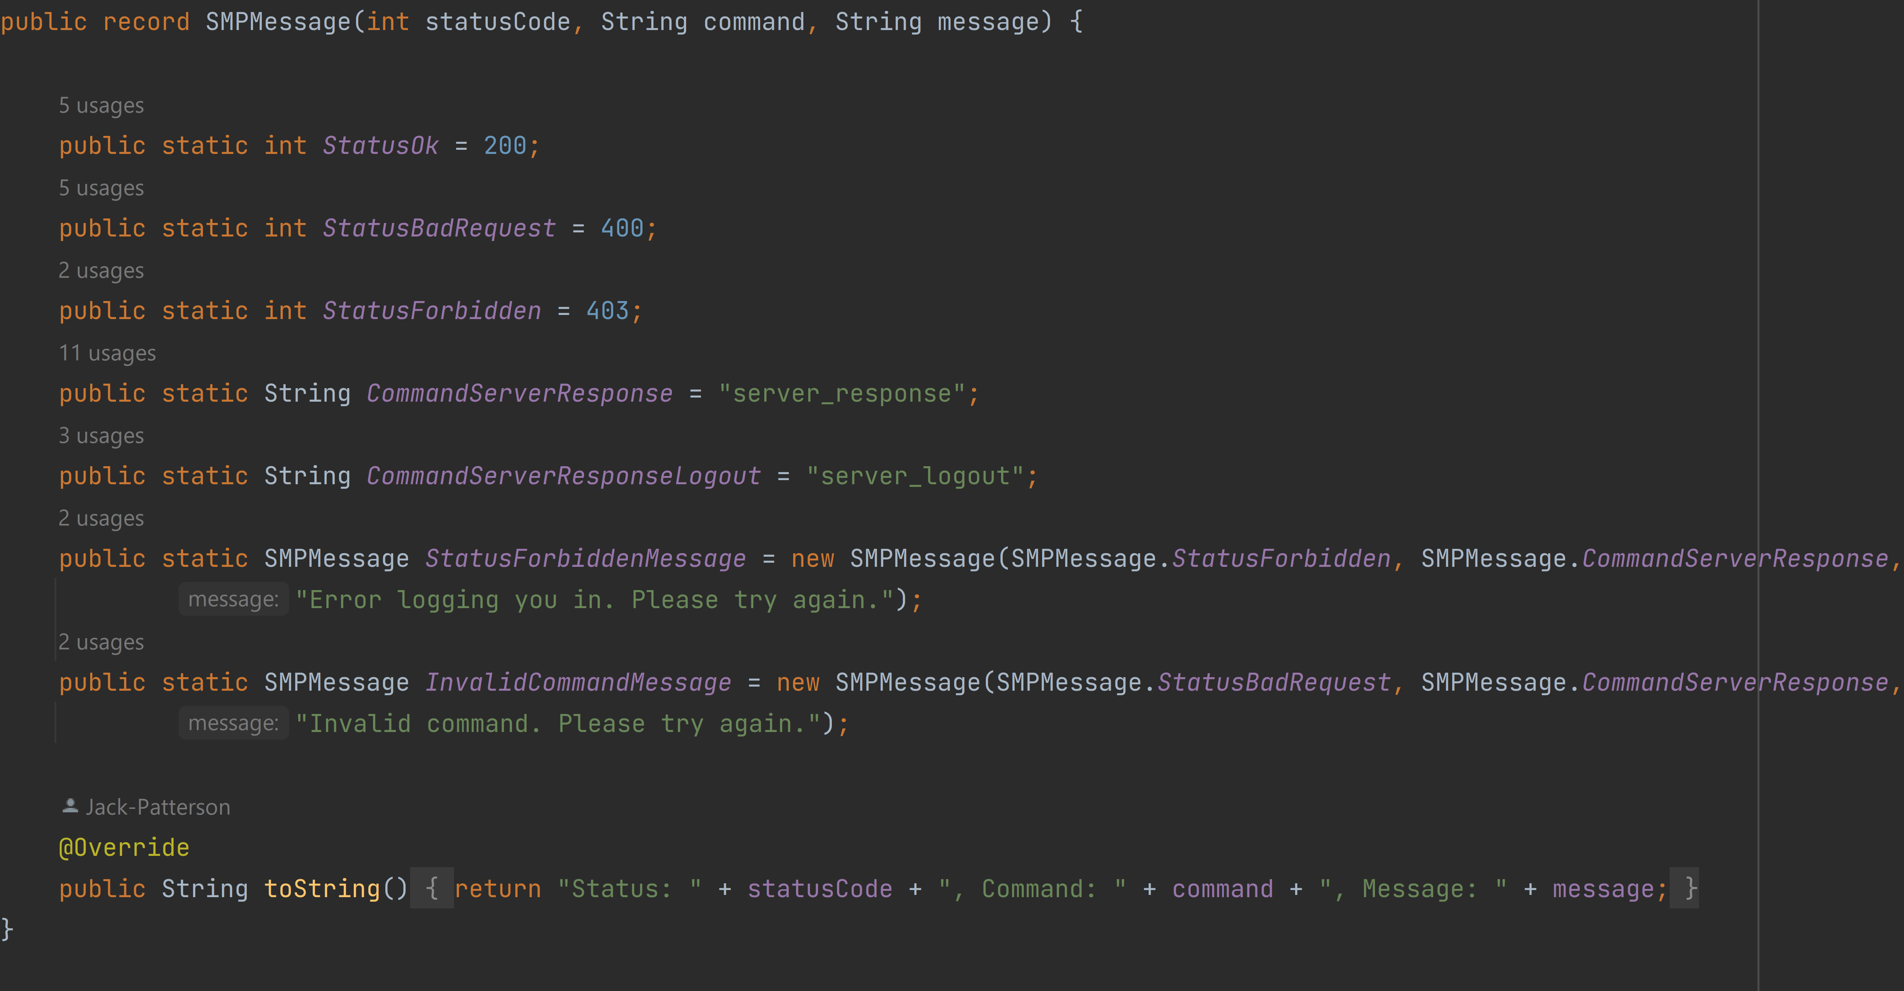

##### 7.3.3 HostData

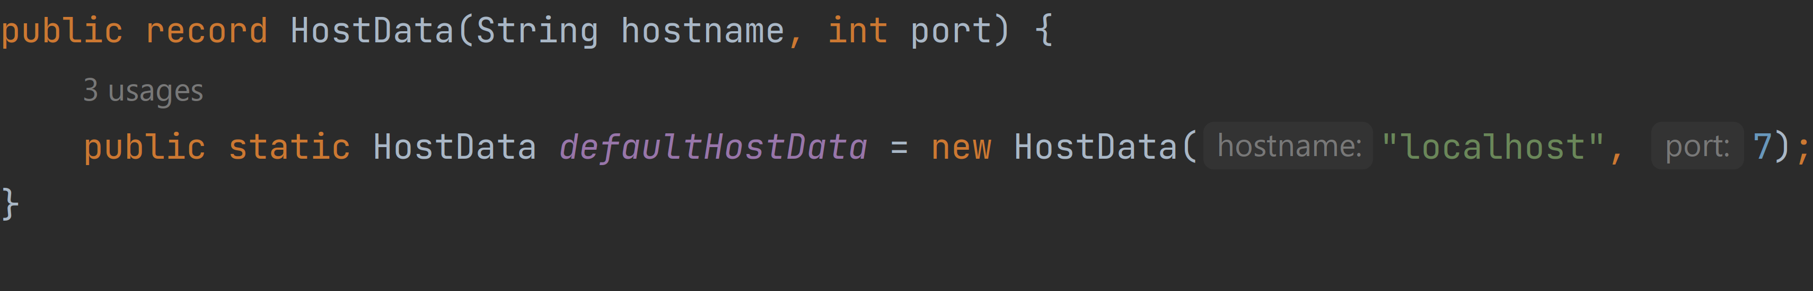

##### 7.3.4 CommandService

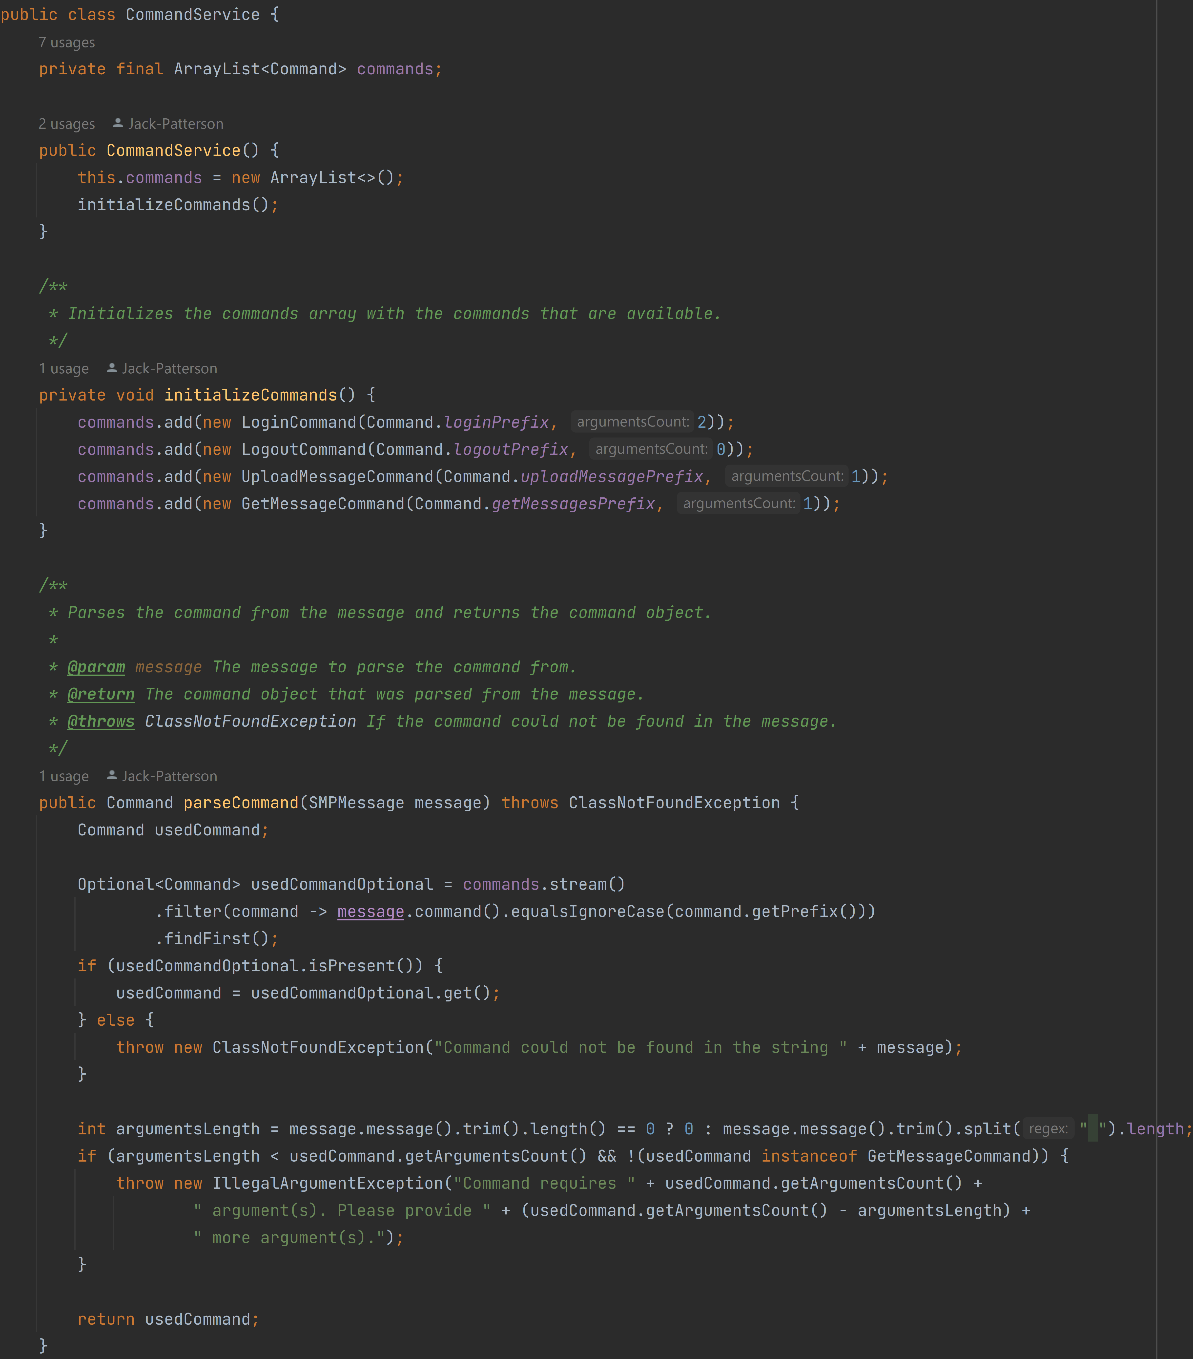

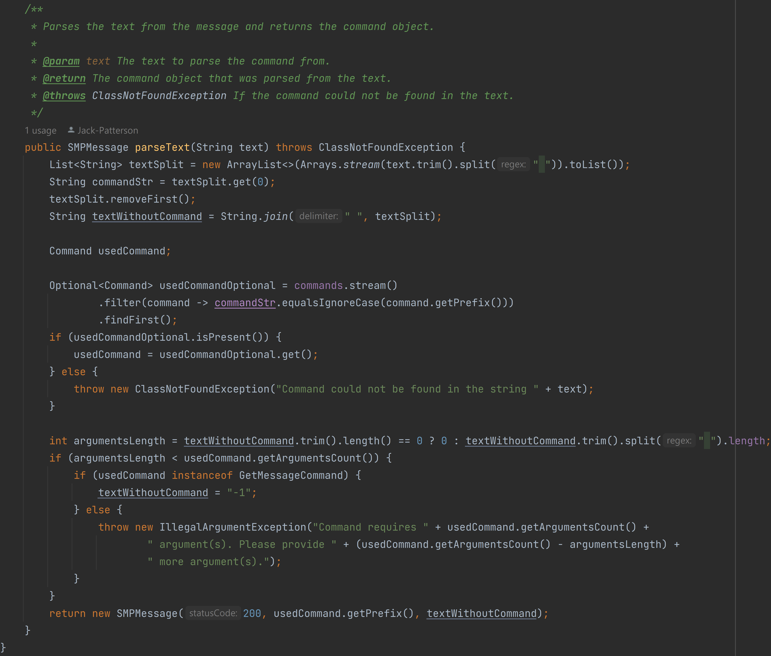

##### 7.3.5 Command

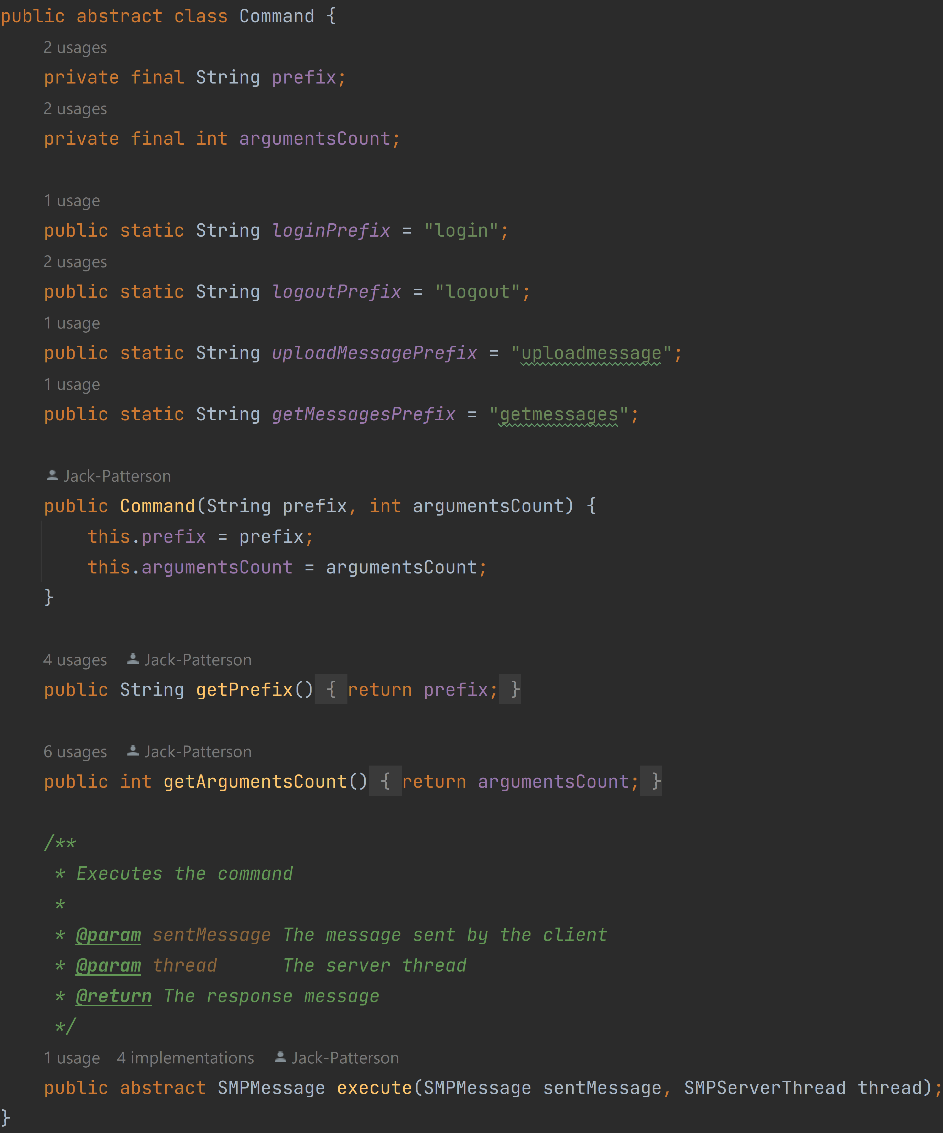

##### 7.3.6 LoginCommand

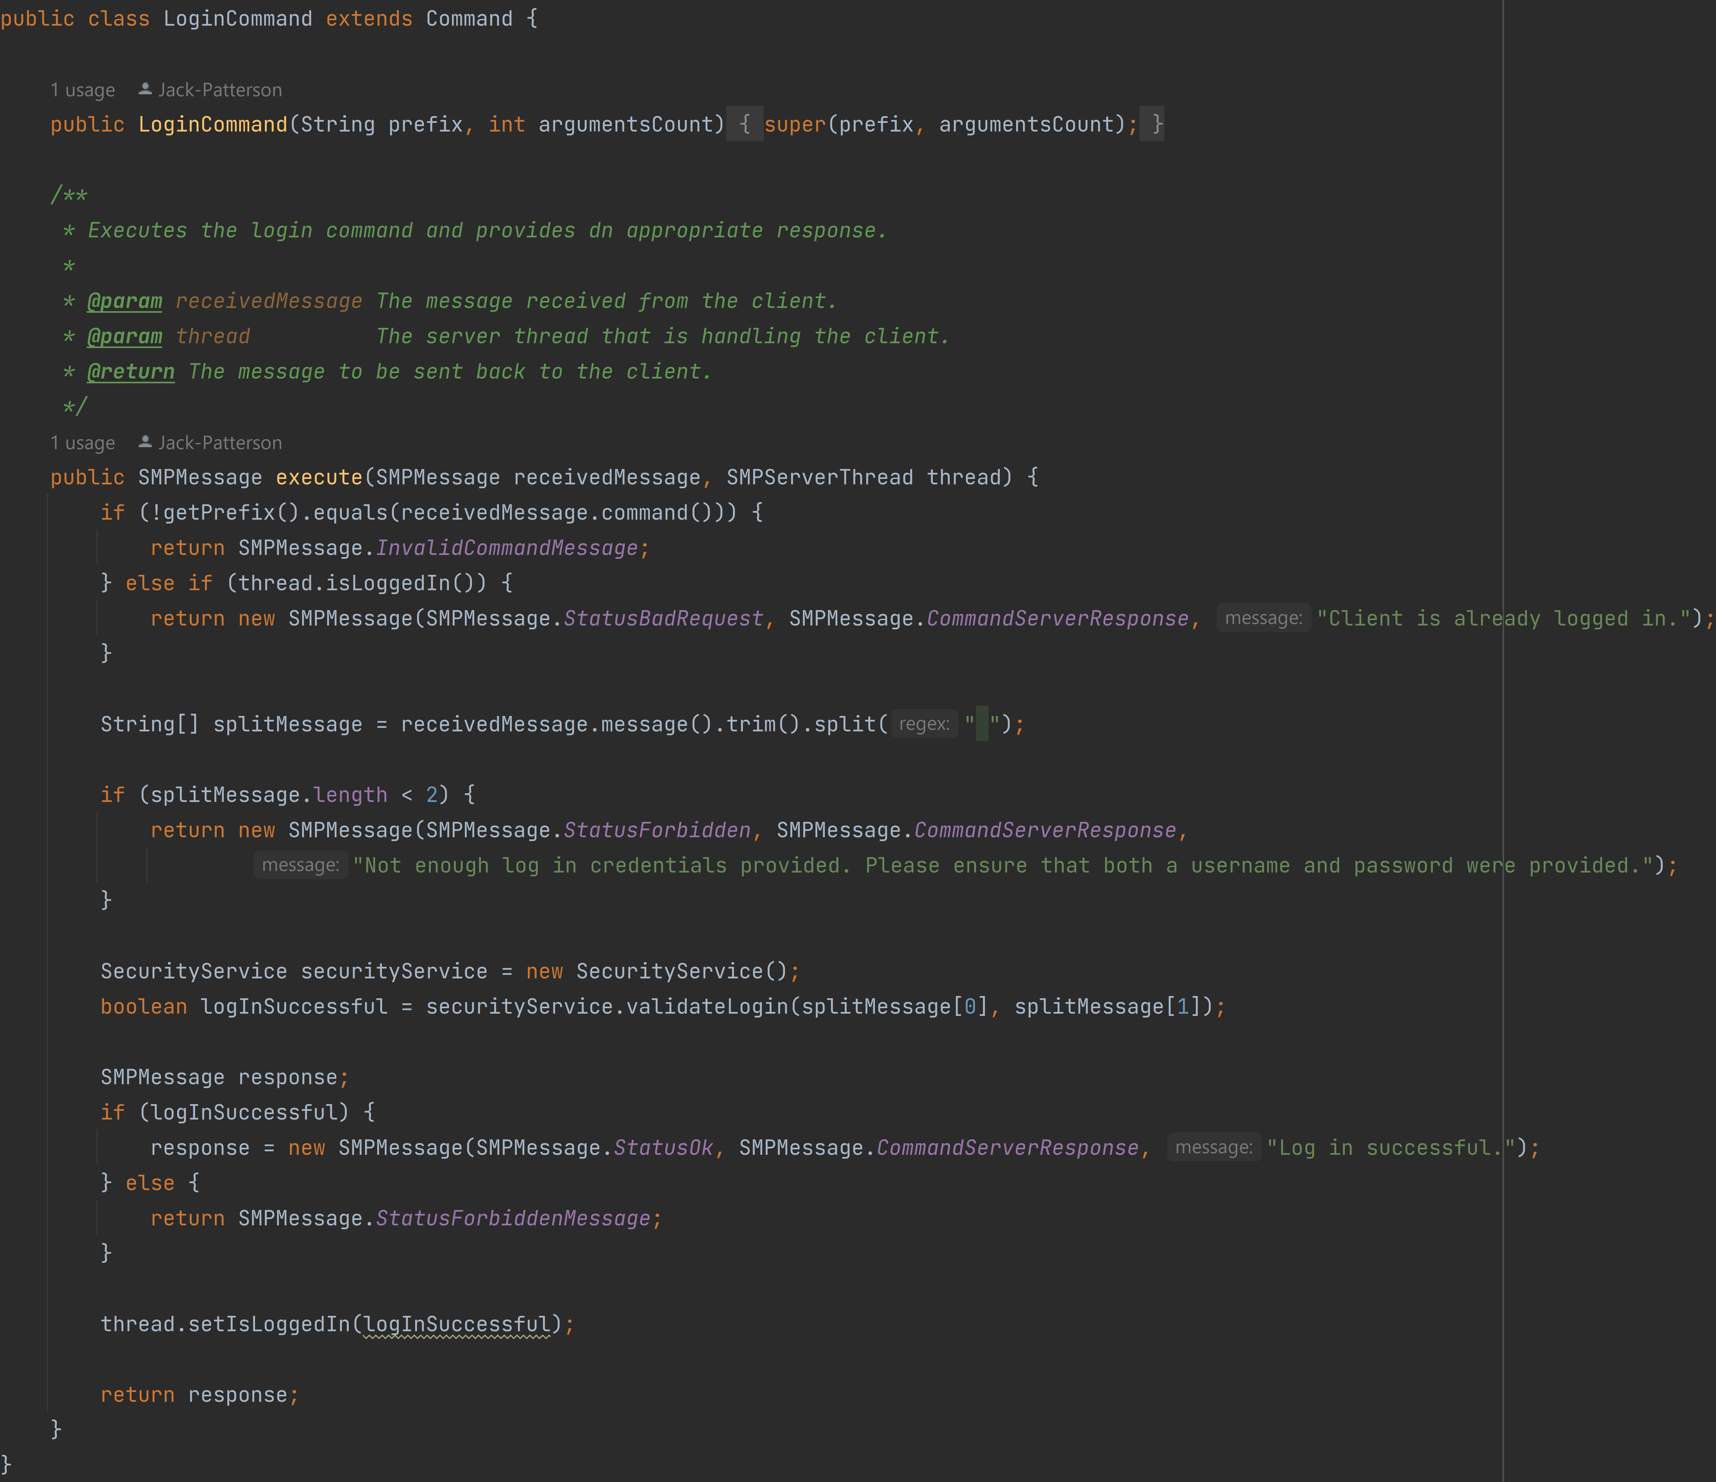

##### 7.3.7 LogoutCommand

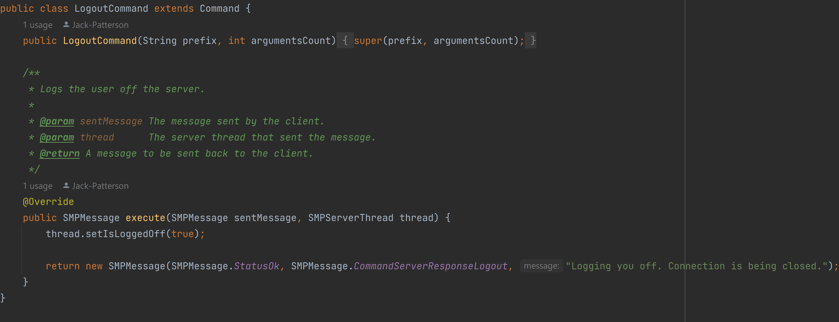

##### 7.3.8 UploadMessageCommand

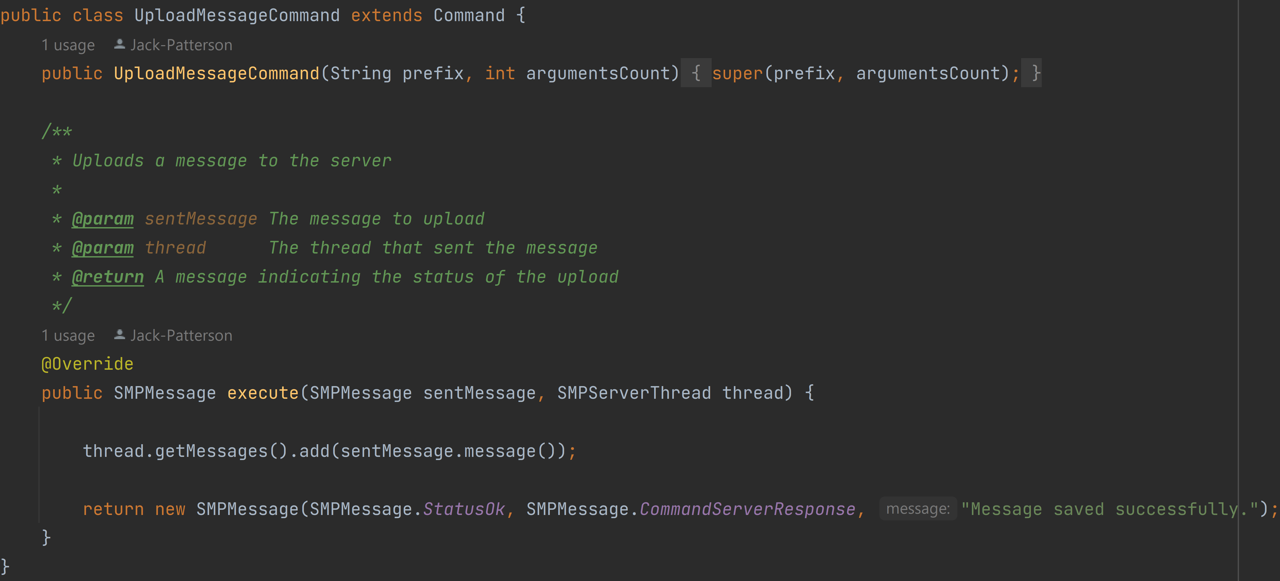

##### 7.3.9 GetMessagesCommand

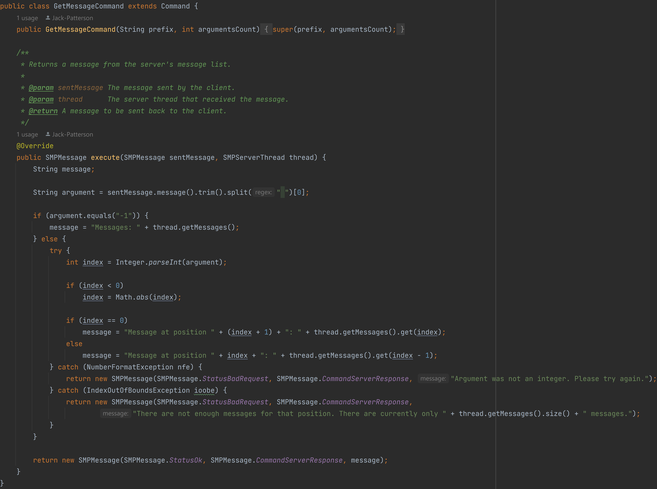

## 8 References

Google, 2024. *GSON - Google JSON.* [Online]   
Available at: https://github.com/google/gson  
[Accessed 12 February 2024].